Question 1:

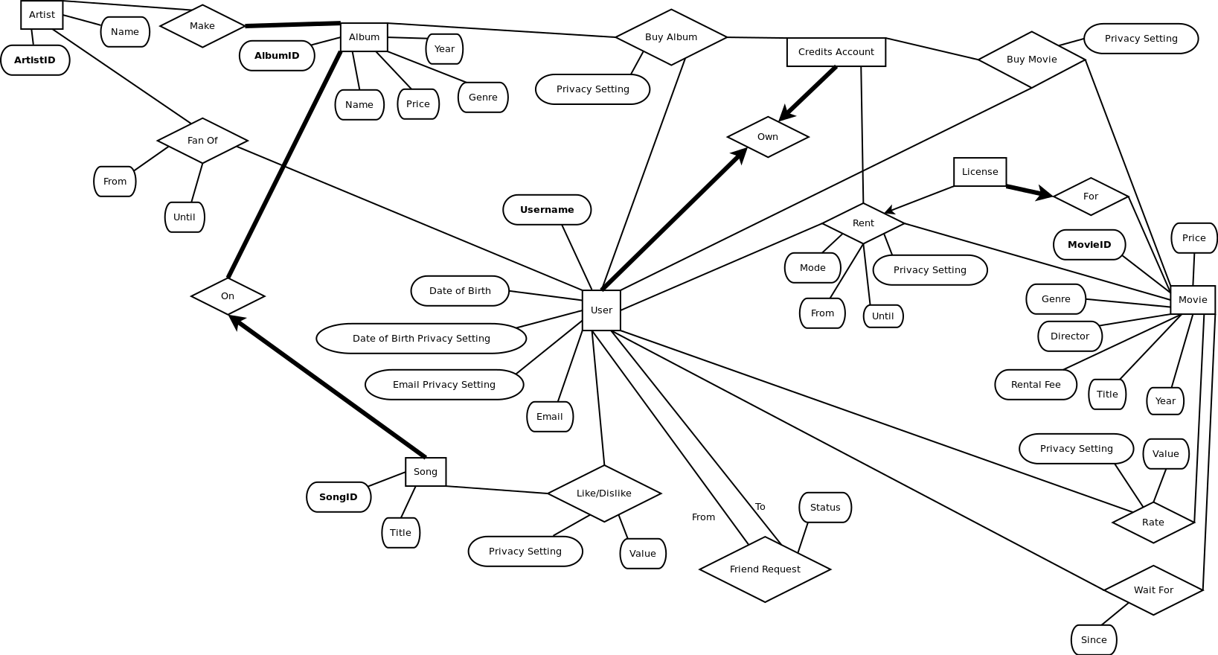

Question 2:

/\* The Is-A group of Employee based Entities \*/

CREATE TABLE Employee (

Eid INTEGER,

Name CHAR[50],

Phnext INTEGER,

PRIMARY KEY (Eid) )

CREATE TABLE Technical (

Eid INTEGER,

Speciality CHAR[50],

PRIMARY KEY (Eid),

FOREIGN KEY (Eid) REFERENCES Employee )

CREATE TABLE Admin (

Eid INTEGER,

Grade INTEGER,

PRIMARY KEY (Eid),

FOREIGN KEY (Eid) REFERENCES Employee )

/\* The other Entities \*/

CREATE TABLE Project (

Id INTEGER,

Name CHAR[50],

Budget FLOAT,

PRIMARY KEY (Id),

FOREIGN KEY (Id) REFERENCES WorksOn )

CREATE TABLE Supplier (

SId INTEGER,

Name CHAR[50],

PRIMARY KEY (SId) )

CREATE TABLE Part (

PId INTEGER,

Name CHAR[50],

PRIMARY KEY (PId),

FOREIGN KEY (PId) REFERENCES Has )

CREATE TABLE PurchaseOrder (

POId INTEGER,

PRIMARY KEY (POId),

FOREIGN KEY (POId) REFERENCES Approves )

CREATE TABLE Depts (

DId INTEGER,

Name CHAR[50],

Budget FLOAT,

PRIMARY KEY (DId),

FOREIGN KEY (DId) REFERENCES Manages )

/\* The Relationships \*/

CREATE TABLE WorksOn (

Eid INTEGER,

Id INTEGER,

PRIMARY KEY (Eid, Id),

FOREIGN KEY (Eid) REFERENCES Technical,

FOREIGN KEY (Id) REFERENCES Project )

CREATE TABLE Sponsors (

SId INTEGER,

Id INTEGER,

Funding FLOAT,

PRIMARY KEY (SId, Id),

FOREIGN KEY (SId) REFERENCES Supplier,

FOREIGN KEY (Id) REFERENCES Project )

CREATE TABLE SBy (

PId INTEGER,

SId INTEGER,

Price INTEGER,

PRIMARY KEY (PId, SId),

FOREIGN KEY (PId) REFERENCES Part,

FOREIGN KEY (SId) REFERENCES Supplier )

CREATE TABLE Has (

POId INTEGER,

PId INTEGER,

PRIMARY KEY (PId),

FOREIGN KEY (POId) REFERENCES PurchaseOrder,

FOREIGN KEY (PId) REFERENCES Part )

CREATE TABLE Places (

Eid INTEGER,

POId INTEGER,

PRIMARY KEY (POId),

FOREIGN KEY (Eid) REFERENCES Technical,

FOREIGN KEY (POId) REFERENCES PurchaseOrder )

CREATE TABLE Approves (

Eid INTEGER,

POId INTEGER,

PRIMARY KEY (POId),

FOREIGN KEY (Eid) REFERENCES Admin,

FOREIGN KEY (POId) REFERENCES PurchaseOrder )

CREATE TABLE IsAt (

Eid INTEGER,

DId INTEGER,

PRIMARY KEY (Eid),

FOREIGN KEY (Eid) REFERENCES Admin,

FOREIGN KEY (DId) REFERENCES Depts )

CREATE TABLE Manages (

Eid INTEGER,

DId INTEGER,

PRIMARY KEY (DId),

FOREIGN KEY (Eid) REFERENCES Admin,

FOREIGN KEY (DId) REFERENCES Depts )